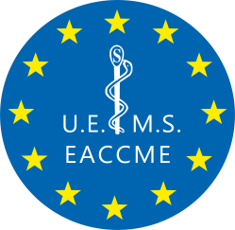
EUROPEAN UNION OF MEDICAL SPECIALISTS ( UEMS)
E U R O P E A N A C C R E D I T A T I O N C O U N C I L F O R C M E ( E A C C M E ® )

RUE DE L’INDUSTRIE 24, BE- 1040 BRUSSELS
T + 32 2 649 51 64

eaccme.uems.eu - accreditation@uems.eu

Conflict of Interest Disclosure Form
(to be completed by Speakers at the 15th European Epilepsy Congress)

NAME: …………………………………………. AFFILIATION: ……………………………………….
In accordance with criterion 13 of document UEMS 2023/07 “EACCME® Criteria for the Accreditation of
Live Educational Events (LEEs)”, all declarations of perceived or actual conflicts of interest for the last 3 years, whether due to a financial or other relationship, must be provided to the EACCME® upon submission of the application. COI declarations signed more than 6 months before the date of the event will not be accepted. Declarations must be made available online on the event website of the LEE. Declarations must include whether any fee, honorarium or arrangement for re-imbursement of expenses in relation to the LEE has been provided.

DISCLOSURE

I have no potential conflict of interest to report
- I have the following potential conflict(s) of interest to report

Type of affiliation / financial interest | Name of commercial company
Receipt of grants/research supports:
Receipt of honoraria or consultation fees:
Participation in a company sponsored speaker’s
bureau:
Stock shareholder:
Spouse/partner:
Other support (please specify):

Signature: Date:

UEMSaisbl – Union Européenne des Médecins Spécialistes VAT n° BE 0469.067.848 RPM Bruxelles-Brussels
EU Transparency Register ID 219038730914-92

